Car Selection Analysis Report

Abhishek Khatti

Western Governors University

# Contents

Contents 2

Synopsis 3

Data Scrape 3

Data Configuration 4

Scores & Weight Information Per Criteria 4

Cleansing, Scoring and Weighting Scraped Data 5

Weighted Decision Matrix 6

Clean Final Combined Data Set 7

Data Presentation 9

Criteria 1 - Safety Features 9

Criteria 1 – Maintenance Cost 10

Criteria 1 – Price Point/Base Price 11

Criteria 2 – Insurance Per Year 12

Criteria 2 – Fuel Economy 13

Criteria 2 – Resale Value/Resale Percentage Return 14

Total Weighted Score in Tableau 15

Dashboard Combining all factors 15

Observed Results & Conclusions 16

Acknowledgment 17

References 18

Car Selection Analysis Report

# Synopsis

The company needs to add a new car to the fleet. The choices are narrowed down to four vehicles: a 2019 Ford Escape, 2019 Honda CRV, 2019 Hyundai Santa Fe, or 2019 Toyota RAV 4. Since the car must be purchased with company funds, the criteria are provided by the company, which are also weighted to help select the vehicle. However, since the personal criteria for choosing a car could be different, this is also considered while selecting the vehicle ("Performance Assessment — ADE2"). The objective of this report is to analyze the data scraped from various resources using different scores and weights per criteria with the help of advanced visualizations. This report provides a summary of the analysis performed on multiple factors from each vehicle by trim, such as the safety features, maintenance cost per year, base price, insurance cost per year, average fuel economy and resale value. In addition, this report also provides a conclusion which car would be best suited according to the selection criteria.

# Data Scrape

The data was scraped manually from various online resources. The data was collected for all 4 vehicles by the trim which is available for that model for 2019. The option to get information by trim was made because, at the time of purchase, it would be very clear which exact vehicle needs to be purchased to avoid potential confusion. In addition, the costs of the vehicle (base price, insurance, maintenance, resale) varies by the trim of the model. The scraped data was placed in “*A & B. Data Scrape - Part 1*” and “*A & B. Data Scrape - Part 2*” worksheet of “Car-Selection-Analysis-Data.xlsx” spreadsheet.

The criteria information, such as maintenance cost per 5 years, base price, insurance cost per month, average fuel economy and resale value by model and trim was scraped in “*A & B. Data Scrape - Part 1*” worksheet of “Car-Selection-Analysis-Data.xlsx” spreadsheet.

The remaining criteria information for safety features was scraped and calculations of costs per year (maintenance, insurance) were performed in “*A & B. Data Scrape - Part 2*” worksheet of “Car-Selection-Analysis-Data.xlsx” spreadsheet.

# Data Configuration

## Scores & Weight Information Per Criteria

All the weights and scoring details for each of criteria is mentioned in “*Weights & Scores Details*” worksheet of “Car-Selection-Analysis-Data.xlsx” spreadsheet.

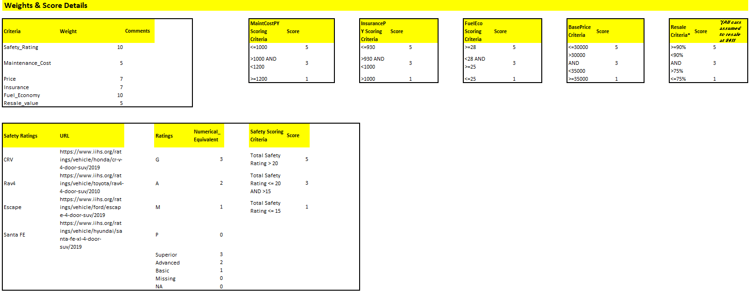

Figure 1. Weights & Scoring Information by Criteria

Weights for Criteria 1 and Criteria 2 data is displayed in the first box. The Criteria 1 weights are provided by the company ("Performance Assessment — ADE2"), which are:

1. Safety Features – 10
2. Maintenance Costs – 5
3. Price Point/Base Price – 7

The weights for Criteria 2 ("Performance Assessment — ADE2") are a personal choice and are as below:

1. Insurance – 7
2. Fuel Economy – 10
3. Resale Value/Percentage Return on Sale – 5

The scoring conditions for each of the above criteria are also available in “*Weights & Scores Details*” worksheet of “Car-Selection-Analysis-Data.xlsx” spreadsheet. The scores for each of the vehicle trim are based on their individual criteria data points scraped from various resources.

The combined total of *Vehicle Trim Criteria Score X Criteria Weight* will result in the weighted score for each of the vehicle trims for every criterion. A sum of weighted scores of all criterions will be then compared within each of the vehicles trims to finalize the recommendation on the car (e-Learning, "Weighted scoring 101 -Learn quickly decision making matrix, ranking & prioritization matrix (long)", 2016).

## Cleansing, Scoring, and Weighting Scraped Data

While scraping the data, the vehicle names included a variety of details which could be irrelevant for the analysis. A list of all vehicle trim names is compiled and all unnecessary details from the vehicle name are removed. This clean list of vehicle names is available in “*Cleaned Trim Names*” worksheet of “Car-Selection-Analysis-Data.xlsx” spreadsheet.   
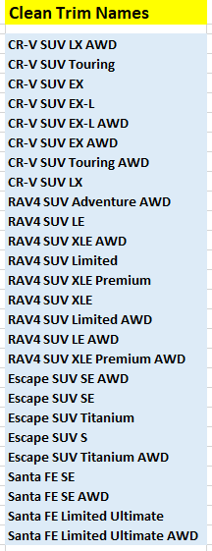

Figure 2. Cleaned Vehicle Trim Names

The vehicle names are then cleaned, and the individual vehicle trims are then scored and weighted based on the conditions and standards mentioned in the “*Weights & Scores Details*” worksheet of “Car-Selection-Analysis-Data.xlsx” spreadsheet. The cleaned data and the weighted scores for each of the vehicle trims are then compiled into the “*C & D. Cleaned Data - I & II*” worksheet of “Car-Selection-Analysis-Data.xlsx” spreadsheet.

## Weighted Decision Matrix

Based on the cleansed and weighted score for each of the criterions per vehicle trim, a “Weighted Decision Matrix” is then created to provide a validation baseline for the dashboards to compare to. The matrix is available in “*Weighted Decision Matrix*” worksheet of “Car-Selection-Analysis-Data.xlsx” spreadsheet (e-Learning, "Weighted scoring 101 -Learn quickly decision making matrix, ranking & prioritization matrix (long)", 2016).

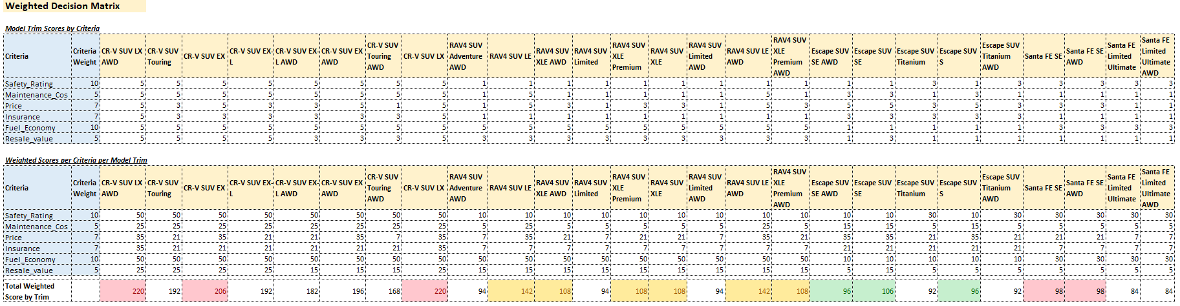

Figure 3. Baseline Weighted Decision Matrix for Dashboard Validations

## Clean Final Combined Data Set

A final combined, cleaned and concise list of data set is created from data present in the “*C & D. Cleaned Data - I & II*” worksheet of “Car-Selection-Analysis-Data.xlsx” spreadsheet. The final data set has the headers streamlined and removal of unwanted attributes, like individual safety scores for each of the vehicle trims. The weighted score attribute for each vehicle and all criteria aspects are also removed from the final list to streamline data sourcing into Tableau. This weighted score is again calculated within Tableau as a calculated measure for each of the vehicle trim. The final data set that is loaded into Tableau is available in “E. Final Cleaned Data Combined” worksheet of “Car-Selection-Analysis-Data.xlsx” spreadsheet.

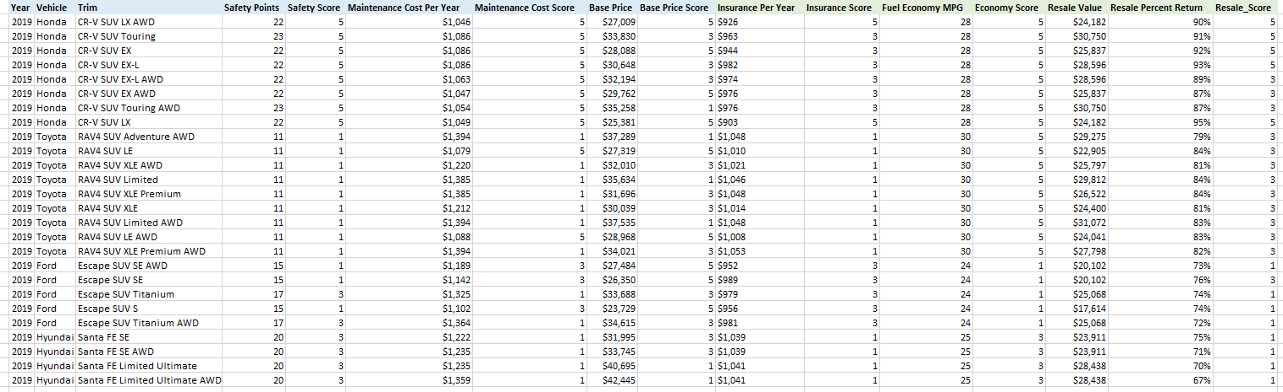

Figure 4. Final Data Set for Tableau

There are 3 dimensions and 13 measures in the final data set. The dimensions from the data set are:

1. Year – Year of Model
2. Make – Make of the Model
3. Model – Name and Trim of the Model

The measures from the data set are:

1. Safety Points – Total points based on Safety Features offered
2. Safety Score – Objective score for the Vehicle based on the Safety Points
3. Maintenance Cost Per Year – Total cost of Maintenance/Year
4. Maintenance Cost Score – Objective score for the Vehicle based on the Maintenance Cost Per Year
5. Base Price – Base price of the Vehicle Trim
6. Base Price Score – Objective score for the Vehicle based on the Base Price
7. Insurance Per Year – Total cost of Insurance/Year
8. Insurance Score – Objective score for the Vehicle based on the Insurance Per Year
9. Fuel Economy MPG – Miles Per Gallon Fuel Economy
10. Economy Score – Objective score for the Vehicle based on the Fuel Economy MPG
11. Resale Value – Potential resale value
12. Resale Percent Return – Percentage Return compared to Base Price
13. Resale Score – Objective score for the Vehicle based on the Resale Percentage Return

# Data Presentation

The company has asked to recommend a car for the company fleet based on certain criterions. These data from these criteria is represented using various ways of visualization to get a better understanding of the data. Each criterion is first looked at separately, then combined information from all the factors will be looked at together in a single dashboard. All the visualization reports are created in Tableau 2019.2 (Tableau, "Tableau Training & Tutorials") and are available in “*Car-Selection-Analysis-Visualizations.pdf*”.

## Criteria 1 - Safety Features

The below figure shows a comparison by Safety Points and Safety Score between each of the vehicle trims. The safest vehicle/trim is 2019 Honda CR-V SUV Touring (normal and AWD) at 23 points and least safe vehicle/trim is 2019 Toyota RAV4 SUV (all trims) at 11 points.

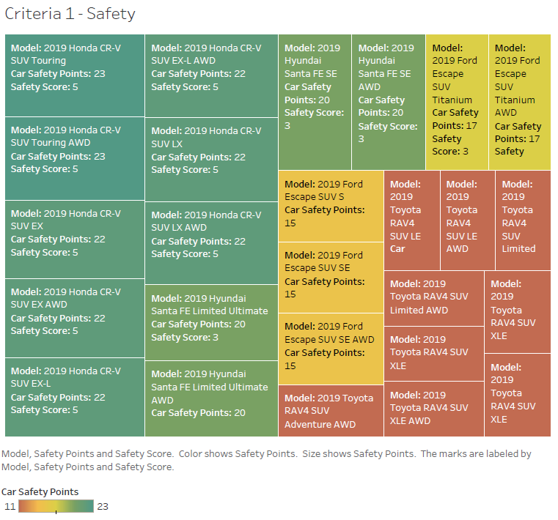

Figure 5. Safety Points & Score by Vehicle Trim

## Criteria 1 – Maintenance Cost

The below figure shows a comparison by Maintenance Cost Per Year and Maintenance Score between each of the vehicle trims. The least expensive vehicle by Maintenance cost is 2019 Honda CR-V SUV LX AWD at $1046/year and least safe vehicle/trim is 2019 Toyota RAV4 SUV XLE Premium AWD at $1394/year. 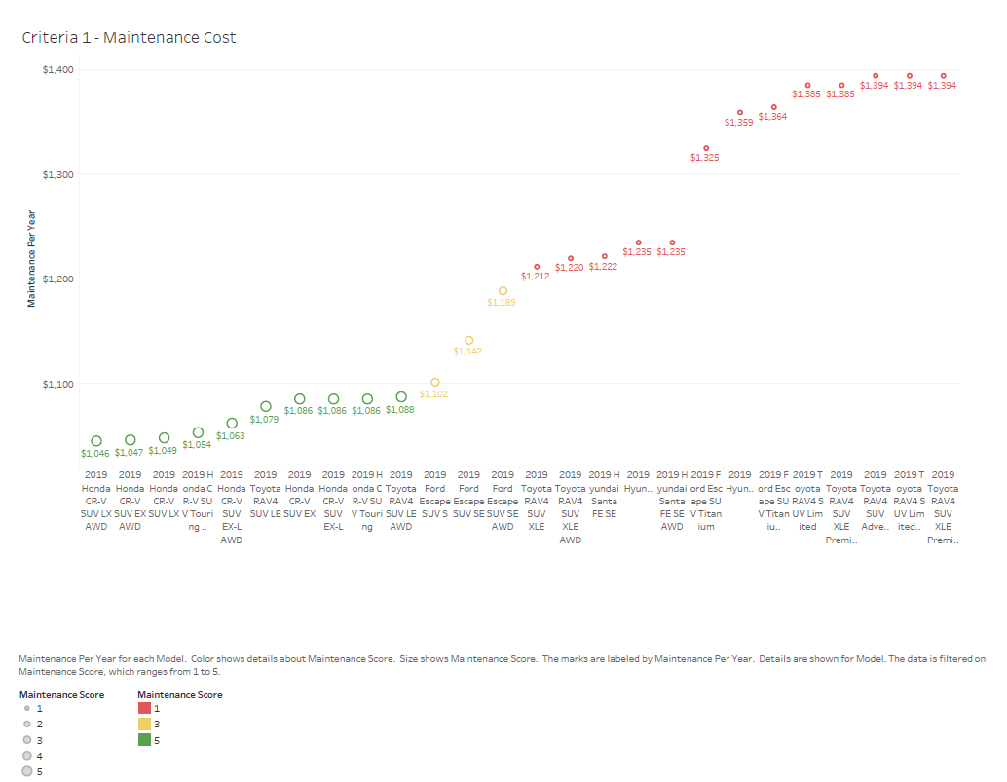

Figure 6. Maintenance Per Year and Maintenance Score by Vehicle Trim

## Criteria 1 – Price Point/Base Price

The below figure shows a comparison by the Base Price and Base Price Score between each of the vehicle trims. The least expensive vehicle by Base Price is 2019 Ford Escape SUV S at $23,729 and most expensive vehicle/trim is 2019 Hyundai Santa Fe Limited Ultimate AWD at $42,445.

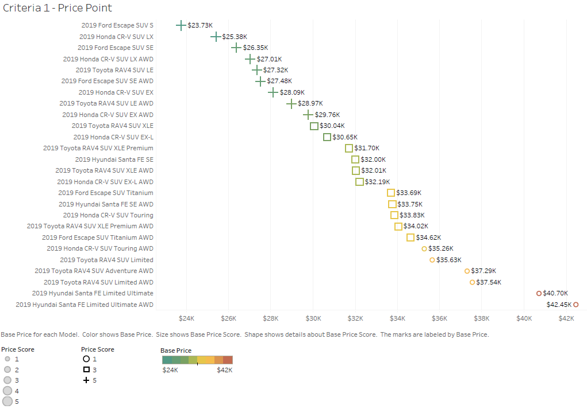

Figure 7. Base Price and Base Price Score by Vehicle/Trim

## Criteria 2 – Insurance Per Year

The below figure shows a comparison by Insurance Per Year cost and Insurance Score between each of the vehicle trims. The least expensive vehicle/trim by Insurance Cost is 2019 Honda CR-V SUV LX at $903/year and most expensive vehicle/trim is 2019 Toyota RAV4 SUV XLE Premium AWD at $1053/year.

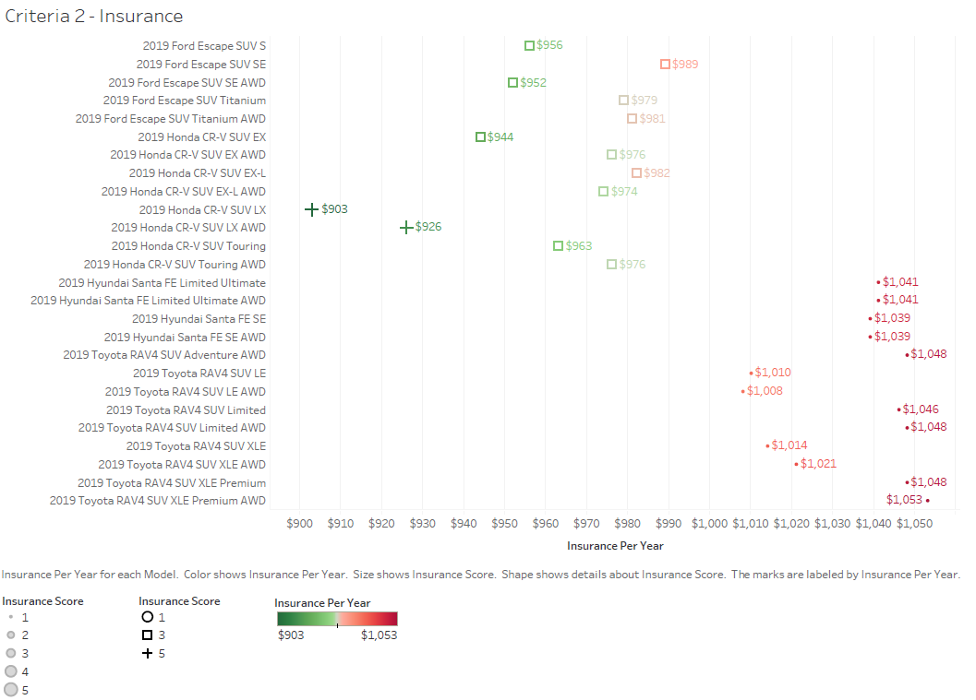

Figure 8. Insurance Per Year and Insurance Score by Vehicle/Trim

## Criteria 2 – Fuel Economy

The below figure shows a comparison by Fuel Economy and Economy Score between each of the vehicle trims. The most fuel-efficient vehicle/trim is 2019 Toyota RAV4 SUV (all trims) at 30 miles/gallon and least fuel-efficient vehicle/trim is 2019 Ford Escape SUV at 24 miles/gallon.

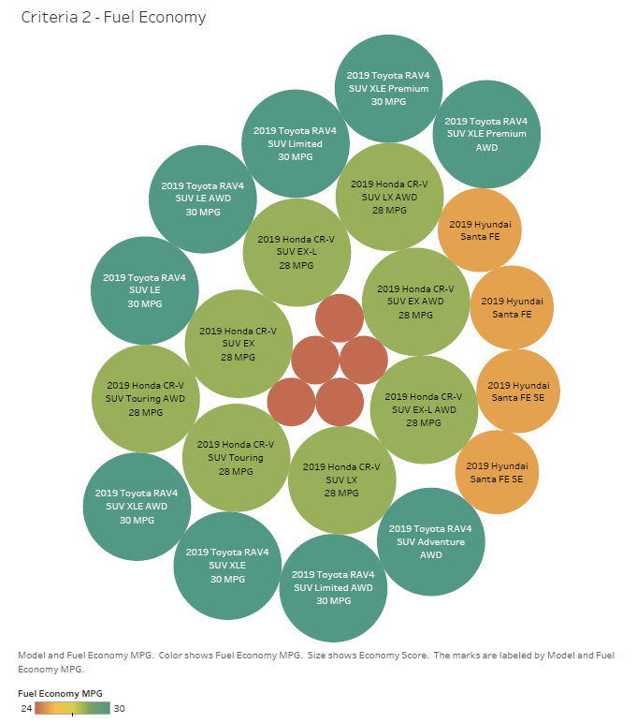

Figure 9. Fuel Economy and Economy Score by Vehicle/Trim

## Criteria 2 – Resale Value/Resale Percentage Return

The below figure shows a comparison by Resale Value/Resale Percentage Return and Resale Score between each of the vehicle trim. The highest return could be expected by 2019 Honda CR-V SUV LX at $24,182 and 95.28% of Base Price and lowest return could be expected by 2019 Hyundai Santa Fe Limited Ultimate AWD at $28,438 and 67% of Base Price.

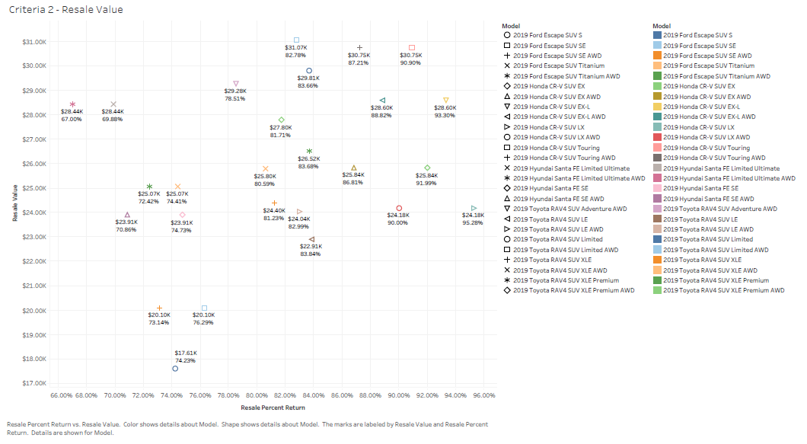

Figure 10. Resale Value by Resale Percent Return by Vehicle/Trim

## Total Weighted Score in Tableau

A total weighted score is calculated in the Tableau to objectively compare various aspects of criterions. It uses scores by each vehicle trim for each criterion and multiplies with the weights for each of the criteria. The formula for the calculation is below:

*[Safety Score]*10+[Maintenance Score]*5+[Base Price Score]*7+[Economy Score]*10+[Insurance Score]*7+[Resale Score]*5*

This score combines values from all 6 criterions and presents a single number that could be used to compare with different models and their trims.

## Dashboard Combining all factors

The below dashboard shows representations of all the data for all six aspects of the criteria in the scenario. The most important factor which combines information from all six aspects of criteria is the Total Weighted Score of each of the vehicle trims. The highest number among all the total weighted scores would result in a confident recommendation of the car to the company.

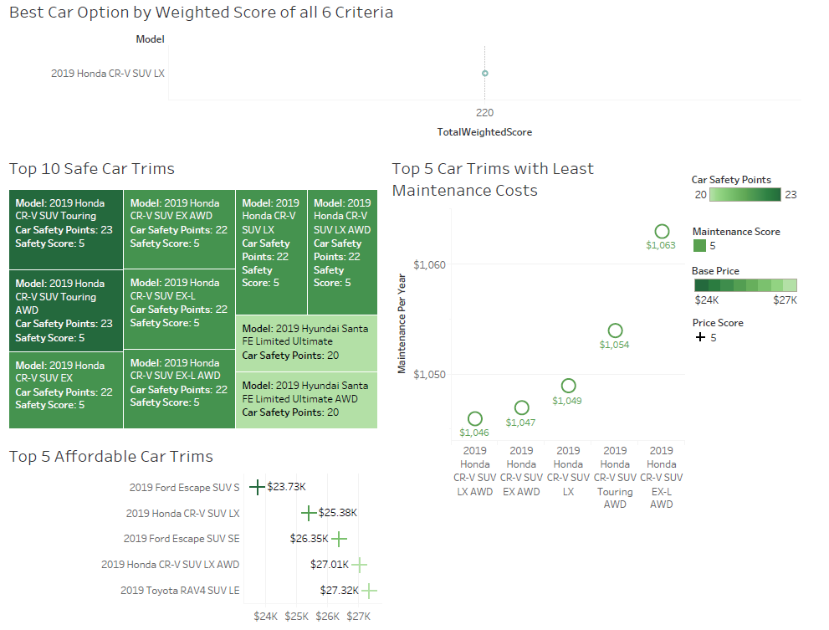

Figure 11. Summary & Best Vehicle Option Dashboard

The dashboard summarized top 10 safest vehicle trims in descending order. It also summarized the top 5 affordable vehicle trims based on their base prices and top 5 trims with least maintenance cost per year.

The dashboard displays the best car option to be recommended to the company based on the total weighted score from all 6 aspects of criteria.

## Observed Results & Conclusions

*After comparing the “Best Car Option by Weighted Score of all 6 Criteria” section of the dashboard to the Baseline Weighted Decision Matrix, it is clear that the best car option given all the 6 criteria is 2019 Honda CR-V SUV LX.*

*Although 2019 Honda CR-V SUV LX and AWD have the same combined weighted score of 220, the base price of the LX trim is less compared to the LX AWD trim. Thus, the LX trim is a clear better option between the two.*

# Acknowledgment

The raw data set was obtained from multiple web sites. The following list of websites was used to scrape the raw data set:

https://www.edmunds.com

https://www.kbb.com/

https://www.hyundaiusa.com/

https://www.iihs.org

The document template for this report was provided by Writing Center team from Student Success Centers, with additional details referred on APA style formatting from WGU Knowledge Center (WGU Knowledge Center, solene, "APA Document Formatting", 2018).

All the sources listed under “Reference” section of this report were used to refer details and instructions to successfully complete this analysis and report.

Finally, sincere gratitude to “William Sewell” for his exceptional guidance, support, and encouragement throughout this course.

# References

W. (n.d.). PERFORMANCE ASSESSMENT — ADE2. Retrieved from https://tasks.wgu.edu/student/001101075/course/11740008/task/966/overview

Tableau Training & Tutorials. (n.d.). Retrieved from https://www.tableau.com/learn/training

E-Learning, A. (2016, October 23). Weighted scoring 101 -Learn quickly decision making matrix, ranking & prioritization matrix (long). Retrieved from https://www.youtube.com/watch?v=HC5SGpn7hAA

S. (2018, March 21). APA Document Formatting. Retrieved from https://cm.wgu.edu/t5/Student-Success-Center-Knowledge/APA-Document-Formatting/ta-p/4606